11.06.2025

AGH, Signals and Systems Krzysztof Smykla

**Lab Assignment 5  
Report**

**Problem 1** – **: Design Lowpass IRR filters**

Design different lowpass IRR filters and compare their amplitude and phase responses. Modify the filter’s order and report the changes in pase and amplitude. Report all observations.

**Task 5.1.** Study and compare amplitude and phase responses of the designed filters for orders of n=3 and n=7:

**a) Butterworth:**

Changing the order of the Butterworth filter modifies the amplitude representation **making the transition band steeper**. The filter **attenuates unwanted frequencies** more quickly. There is less leakage into the stopband.

**b) Chebyshev Type I:**

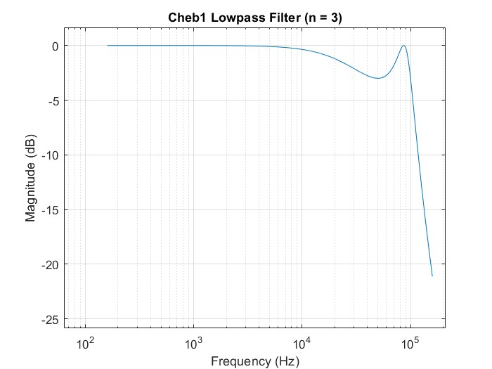

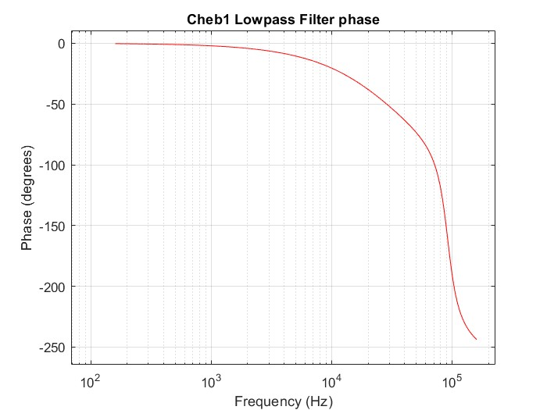

The Chebyshev filter has more ripple in the pass band than the Butterworth filter. **The cutoff of the transition band** in the Chebyshev I filter **is steeper and the pass band has more ripple** with a higher order. The phase graph is more distorted.

**c) Chebyshev Type II:**

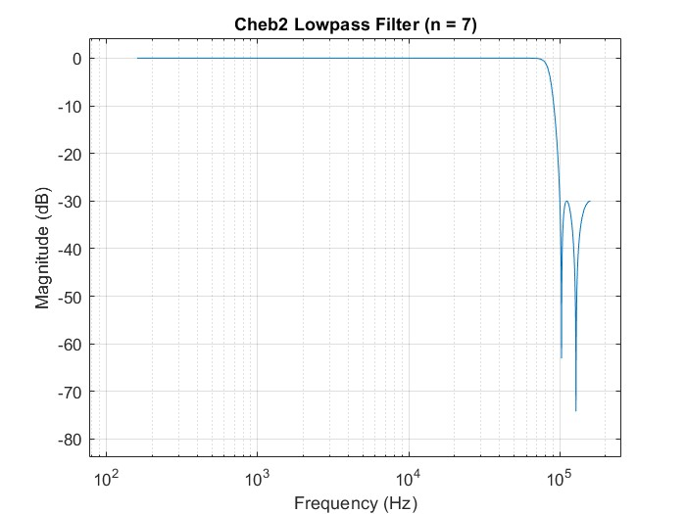

Compared with the Chebyshew1 filter, the Chebyshew 2 filter has a **smoother pass band** and a **smoother transition band** of the frequency response but a more **distorted phase response**.

**d) Elliptic:**

The Eliptic filter introduces high distortion of the phase response with increasing order. The stop band of the filter’s frequency response also has significant ripple.

**Task 5.2.** : Replace the *elliptic filter* with *Bessel filter*. Compare the results of its amplitude and phase response with other filters

**e) Bessel:**

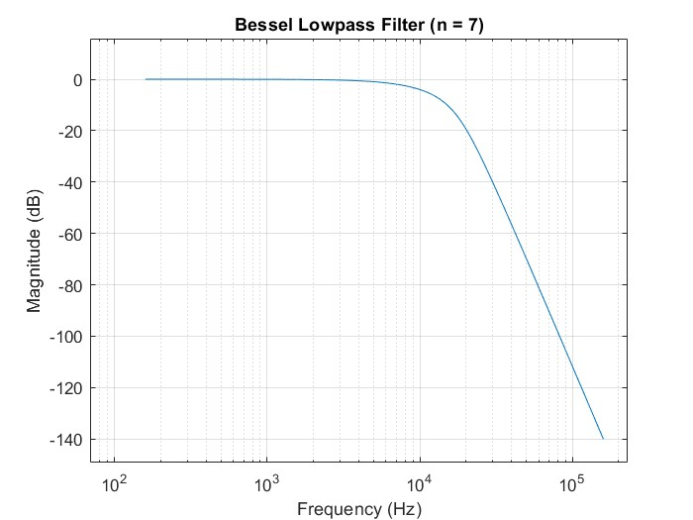

The Bessel has the smoothest transition band out of all filters. There is no ripple in the pass band. The phase shift across the passband is nearly linear preserving the shape of the filtered signal.

**Reaction to an increase in filter order**

**Summary by Filter Type:**

|  |  |  |
| --- | --- | --- |
| **Filter** | **High Order Effects** | **Notes** |
| **Butterworth** | **Smoother roll-off, better attenuation, moderate phase distortion** | **Balanced filter** |
| **Chebyshev I** | **Sharper roll-off, passband ripple, more phase distortion** | **Fast cutoff** |
| **Chebyshev II** | **Sharper roll-off, no passband ripple, but stopband ripple** | **Fast cutoff, less passband distortion** |
| **Elliptic** | **Sharpest cutoff, ripple in both passband and stopband, max phase distortion** | **Most efficient** |
| **Bessel** | **Very smooth magnitude, excellent linear phase, very slow roll-off** | **Ideal for preserving waveform** |

Increasing filter order improves frequency selectivity (better attenuation of unwanted frequencies in the stop band) but worsens phase linearity (increased distortion of the phase response) except for Bessel filters.

**Conclusions:**

* As filter order increases, **amplitude responses become steeper**, leading to better selectivity but more phase distortion (except Bessel).
* **Elliptic filters** provide the **sharpest** cutoff but with **significant phase distortion**.
* **Butterworth filters** offer a **smooth magnitude and phase transition**, ideal when moderate roll-off and linear phase are both needed.
* **Bessel filters** maintain **linear phase**, making them ideal for applications like audio or data where signal shape is important, even though they offer **poor attenuation** compared to others.

**Summary plot:**

The plots below show a comparison of the frequency and phase responses of the given filters on two separate graphs.

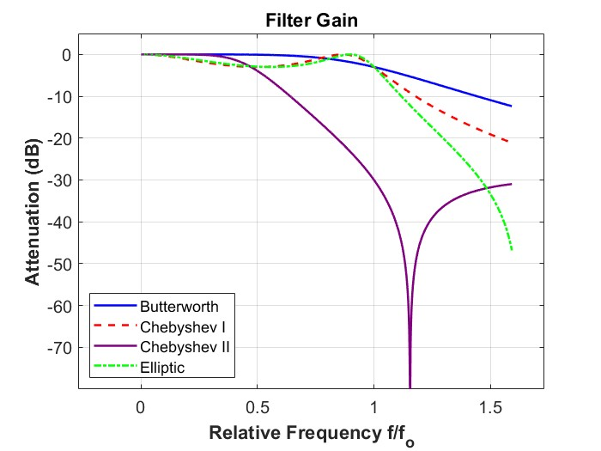

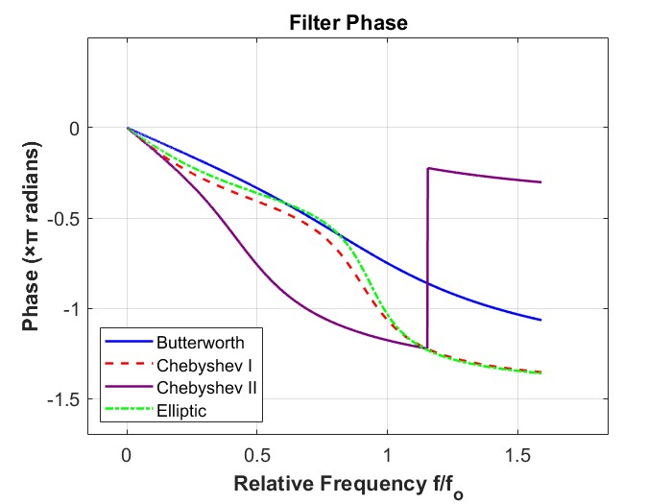

## Filter Order Effects Summary:

As the filter order increases, we observe a clear trend across all filter types: the transition from passband to stopband becomes sharper, allowing for better attenuation of undesired frequencies. However, this improvement comes at a cost—most notably in phase linearity. Butterworth filters maintain a balance between selectivity and phase distortion, while Chebyshev and Elliptic filters prioritize steep cutoff at the expense of ripple and phase behavior. Elliptic filters, though highly efficient, produce significant phase distortion and ripple in both bands. In contrast, Bessel filters show the slowest magnitude roll-off but preserve signal shape due to their nearly linear phase, making them optimal for applications like audio and communication systems where time-domain fidelity is critical.